**Project management board**

The project management was carried out using Jira software using an agile environment.

My Jira link:

<https://lharrold.atlassian.net/secure/RapidBoard.jspa?rapidView=3&projectKey=TDLP>

Below are all of the user stories I created for my project

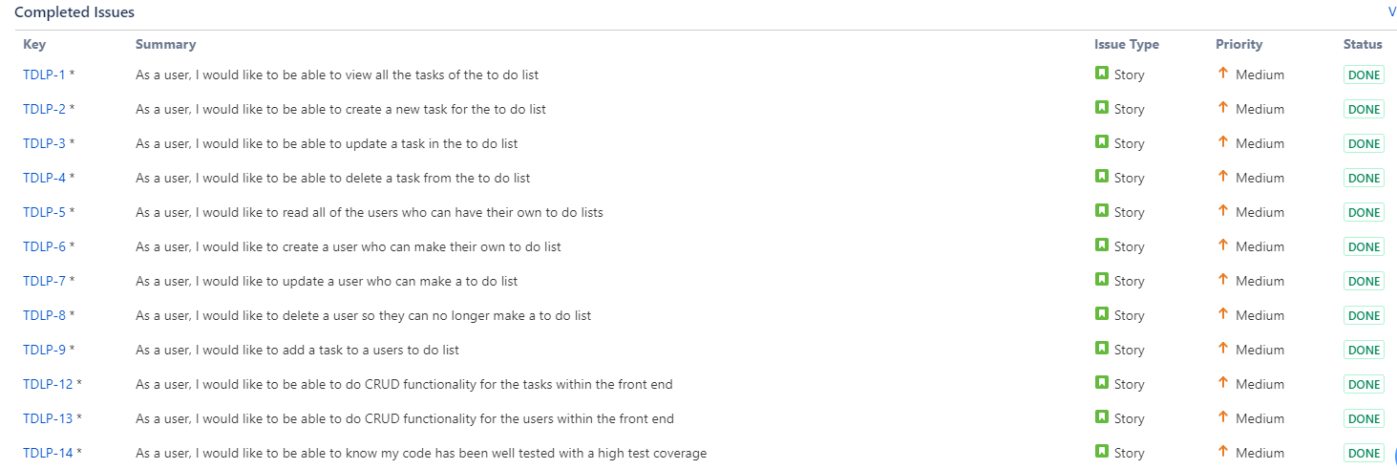

The graph below is a cumulative workflow diagram to show how I progressed throughout my sprint

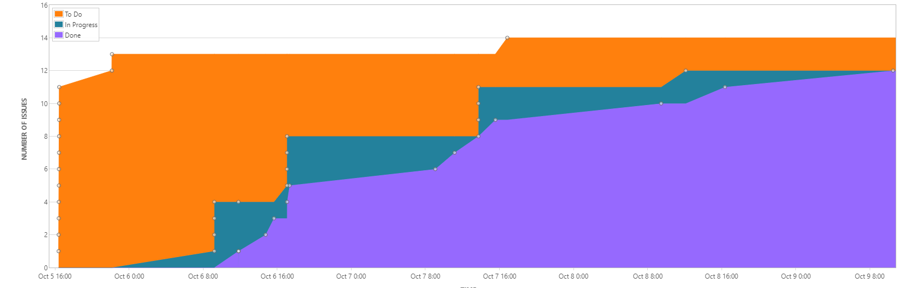

The graph shows that I worked through the project methodically gradually completing more tasks over time.